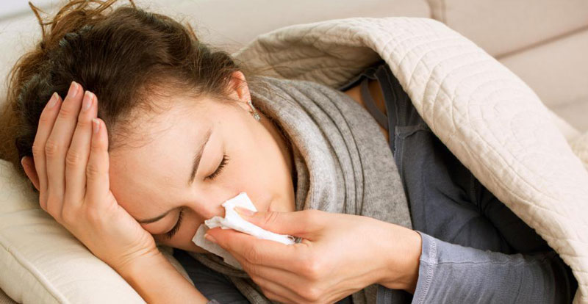

8 things that can weaken your immune system
Increasing your risk to illness & disease

The immune system is the most important system of the body when it comes to preventing diseases. There are many things that can weaken an adequately strong immune system.
The immune system defends the body from developing potentially harmful diseases and conditions caused by bacterial, parasitic, fungal and viral infections. The immune system also restricts tumours and cancerous growths inside the body.
However, problems with the immune system can lead to illnesses and infections. Immune responses can be weakened by various external influences.
1. Stress
People like to ignore it but stress has a major influence on your immune system. Chronic stress -- caused by stressful situations or events that last over a long period of time -- raises cortisol levels of the body which decreases the production of 'good' prostaglandins. Good' prostaglandins are localized hormone like cellular messengers that support immune function, dilate blood vessels, inhibit 'thick' blood and are anti-inflammatory.


2. A poor diet
Prolonged and excessive consumption of refined sugars and highly processed foods containing pesticides, chemical additives, and preservatives can weaken the immune system and make you vulnerable to developing chronic conditions.

Alcohol, like sugar, consumed in excess can reduce the ability of white blood cells to kill germs. Damage to the immune system increases in proportion to the quantity of alcohol consumed.
In the short term, excess alcohol intake will increase the number of colds you will experience.
In the long term, alcohol can impede the functioning of immune cells, increasing your susceptibility to infectious diseases and cancer.
3. Excessive alcohol

Without adequate sleep, the immune system doesn't get a chance to rebuild, and it becomes weak. Poor sleep is associated with reduced number of T-cells, white blood cells that help the body fight disease.
Many studies show that people who don't get a good night's sleep or who don't get enough sleep (sleeping under seven hours a night) are more likely to get sick after being exposed to a virus, such as the common cold.
4. Lack of sleep


5. Lack of exercise
During moderate exercising, blood flow increases which promotes the process of expelling toxic waste out of your body. The improved blood circulation also promotes circulation of antibodies and white blood cells that are important for fighting off infections.
As little as 20 minutes of walking five days a week can help your immune system perform at its best. According to one research, inactive people took twice as many sick days in 4 months when compared to people who walked briskly almost every day.



Some prescription and non-prescription drugs contain major toxins that many put into their bodies. Excessive use of antibiotics and cold and fever fighting medications weakens your immune system.
Researchers found that certain people taking antibiotics had reduced levels of cytokines -- the hormone messengers of the immune system. You are more likely to develop resistant bacteria or become sick in the future when your immune system is suppressed.

6. Medications
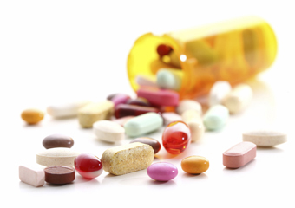

7. Smoking
Cigarettes contain over 4,000 chemicals, all of which are extremely toxic to the body. The more toxic substances in your body, the weaker is the immune system.

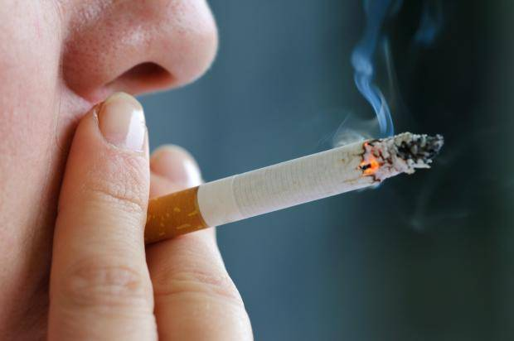
8. Dehydration
It is vital to maintain a good level of hydration to assist in eliminating by-products of any illness and help the immune system fight off infection. Dehydration can affect your energy and your sleep, and the ability to get toxins/waste material out of the body.


By making some simple lifestyle changes, using natural supplements that support a depressed immune system, this can have a very positive effect on your overall health and well-being.
Remember, you have only one line of defence. Better make it the best one! Peter Rea

Are you interested in taking control of your health naturally? Would you like to earn an income working from home sharing our wonderful therapeutic essential oils?
If so we would love to hear from you.
You would be partnering with a global company and the world leader in therapeutic grade essential oils. You will be offering people our wonderful products as an option to using over the counter drugs and medication for everyday health related issues and overall well-being.
For FREE INSTANT information go to www.NaturalWellnessBusiness.com

